**DAY-3**

17.Illustrate the deadlock avoidance concept by simulating Banker’s algorithm with C.

PROGRAM

#include <stdio.h>

#include <stdbool.h>

#define NUM_PROCESSES 5

#define NUM_RESOURCES 3

int available[NUM_RESOURCES] = {3, 3, 2};

int maximum[NUM_PROCESSES][NUM_RESOURCES] = {

{7, 5, 3},

{3, 2, 2},

{9, 0, 2},

{2, 2, 2},

{4, 3, 3}

};

int allocation[NUM_PROCESSES][NUM_RESOURCES] = {

{0, 1, 0},

{2, 0, 0},

{3, 0, 2},

{2, 1, 1},

{0, 0, 2}

};

int need[NUM_PROCESSES][NUM_RESOURCES];

void calculate_need() {

for (int i = 0; i < NUM_PROCESSES; i++) {

for (int j = 0; j < NUM_RESOURCES; j++) {

need[i][j] = maximum[i][j] - allocation[i][j];

}

}

}

bool is_safe() {

bool finish[NUM_PROCESSES] = {false};

int work[NUM_RESOURCES];

for (int i = 0; i < NUM_RESOURCES; i++) {

work[i] = available[i];

}

while (true) {

bool found = false;

for (int i = 0; i < NUM_PROCESSES; i++) {

if (!finish[i]) {

bool possible = true;

for (int j = 0; j < NUM_RESOURCES; j++) {

if (need[i][j] > work[j]) {

possible = false;

break;

}

}

if (possible) {

for (int j = 0; j < NUM_RESOURCES; j++) {

work[j] += allocation[i][j];

}

finish[i] = true;

found = true;

}

}

}

if (!found) {

break;

}

}

for (int i = 0; i < NUM_PROCESSES; i++) {

if (!finish[i]) {

return false;

}

}

return true;

}

bool request_resources(int process_id, int request[]) {

for (int i = 0; i < NUM_RESOURCES; i++) {

if (request[i] > need[process_id][i]) {

printf("Error: Process has exceeded its maximum claim.\n");

return false;

}

if (request[i] > available[i]) {

printf("Error: Resources not available.\n");

return false;

}

}

for (int i = 0; i < NUM_RESOURCES; i++) {

available[i] -= request[i];

allocation[process_id][i] += request[i];

need[process_id][i] -= request[i];

}

if (is_safe()) {

printf("Resources allocated successfully.\n");

return true;

} else {

for (int i = 0; i < NUM_RESOURCES; i++) {

available[i] += request[i];

allocation[process_id][i] -= request[i];

need[process_id][i] += request[i];

}

printf("Error: System is not in a safe state.\n");

return false;

}

}

void print_state() {

printf("Current state:\n");

printf("Available resources:\n");

for (int i = 0; i < NUM_RESOURCES; i++) {

printf("%d ", available[i]);

}

printf("\n");

printf("Maximum resources:\n");

for (int i = 0; i < NUM_PROCESSES; i++) {

for (int j = 0; j < NUM_RESOURCES; j++) {

printf("%d ", maximum[i][j]);

}

printf("\n");

}

printf("Allocated resources:\n");

for (int i = 0; i < NUM_PROCESSES; i++) {

for (int j = 0; j < NUM_RESOURCES; j++) {

printf("%d ", allocation[i][j]);

}

printf("\n");

}

printf("Need resources:\n");

for (int i = 0; i < NUM_PROCESSES; i++) {

for (int j = 0; j < NUM_RESOURCES; j++) {

printf("%d ", need[i][j]);

}

printf("\n");

}

}

int main() {

calculate_need();

print_state();

int process_id = 1;

int request[] = {1, 0, 2};

printf("Process %d requesting resources:\n", process_id);

for (int i = 0; i < NUM_RESOURCES; i++) {

printf("%d ", request[i]);

}

printf("\n");

request_resources(process_id, request);

print_state();

return 0;

}

OUTPUT

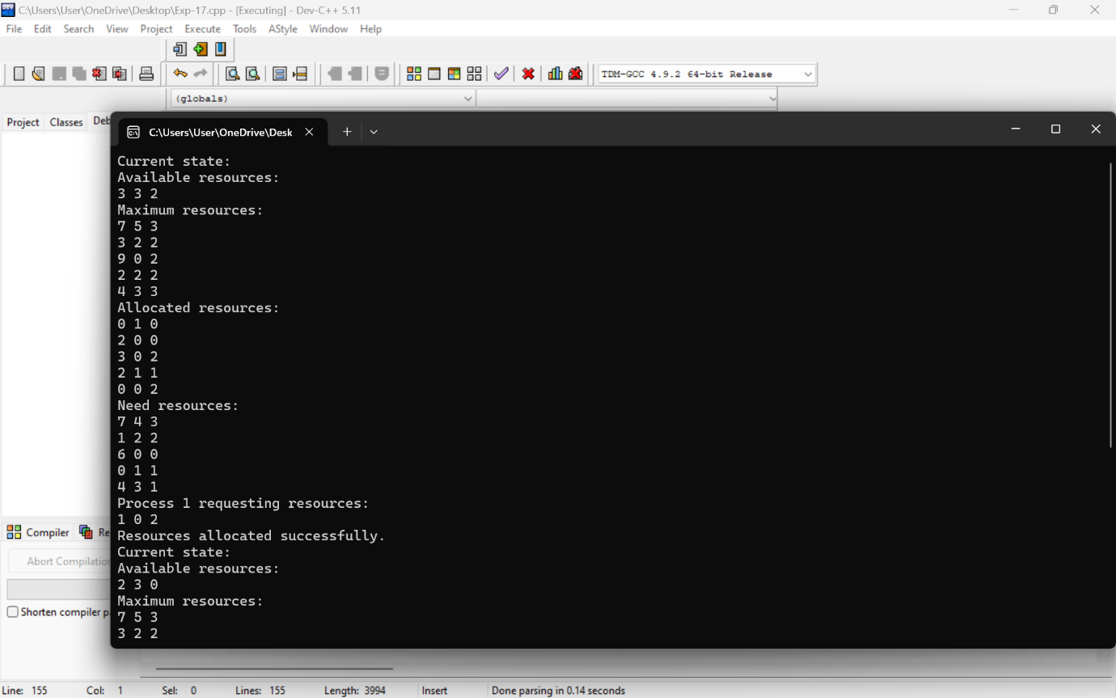

18.Construct a C program to simulate producer-consumer problem using semaphores.

PROGRAM

#include <stdio.h>

#include <stdlib.h>

#include <pthread.h>

#include <semaphore.h>

#define BUFFER_SIZE 10

#define NUM_ITEMS 20

int buffer[BUFFER_SIZE];

int in = 0, out = 0;

sem_t empty;

sem_t full;

pthread_mutex_t mutex;

void* producer(void* arg) {

for (int i = 0; i < NUM_ITEMS; i++) {

// Produce an item (here, just the index for simplicity)

int item = i;

// Wait for an empty slot

sem_wait(&empty);

// Lock the buffer

pthread_mutex_lock(&mutex);

// Add the item to the buffer

buffer[in] = item;

in = (in + 1) % BUFFER_SIZE;

printf("Produced: %d\n", item);

// Unlock the buffer

pthread_mutex_unlock(&mutex);

// Signal that there's a new item in the buffer

sem_post(&full);

}

return NULL;

}

void* consumer(void* arg) {

for (int i = 0; i < NUM_ITEMS; i++) {

// Wait for a filled slot

sem_wait(&full);

// Lock the buffer

pthread_mutex_lock(&mutex);

// Remove the item from the buffer

int item = buffer[out];

out = (out + 1) % BUFFER_SIZE;

printf("Consumed: %d\n", item);

// Unlock the buffer

pthread_mutex_unlock(&mutex);

// Signal that there's an empty slot in the buffer

sem_post(&empty);

}

return NULL;

}

int main() {

pthread_t prod_thread, cons_thread;

// Initialize the semaphores and mutex

sem_init(&empty, 0, BUFFER_SIZE);

sem_init(&full, 0, 0);

pthread_mutex_init(&mutex, NULL);

// Create the producer and consumer threads

pthread_create(&prod_thread, NULL, producer, NULL);

pthread_create(&cons_thread, NULL, consumer, NULL);

// Wait for the threads to finish

pthread_join(prod_thread, NULL);

pthread_join(cons_thread, NULL);

// Destroy the semaphores and mutex

sem_destroy(&empty);

sem_destroy(&full);

pthread_mutex_destroy(&mutex);

return 0;

}

OUTPUT

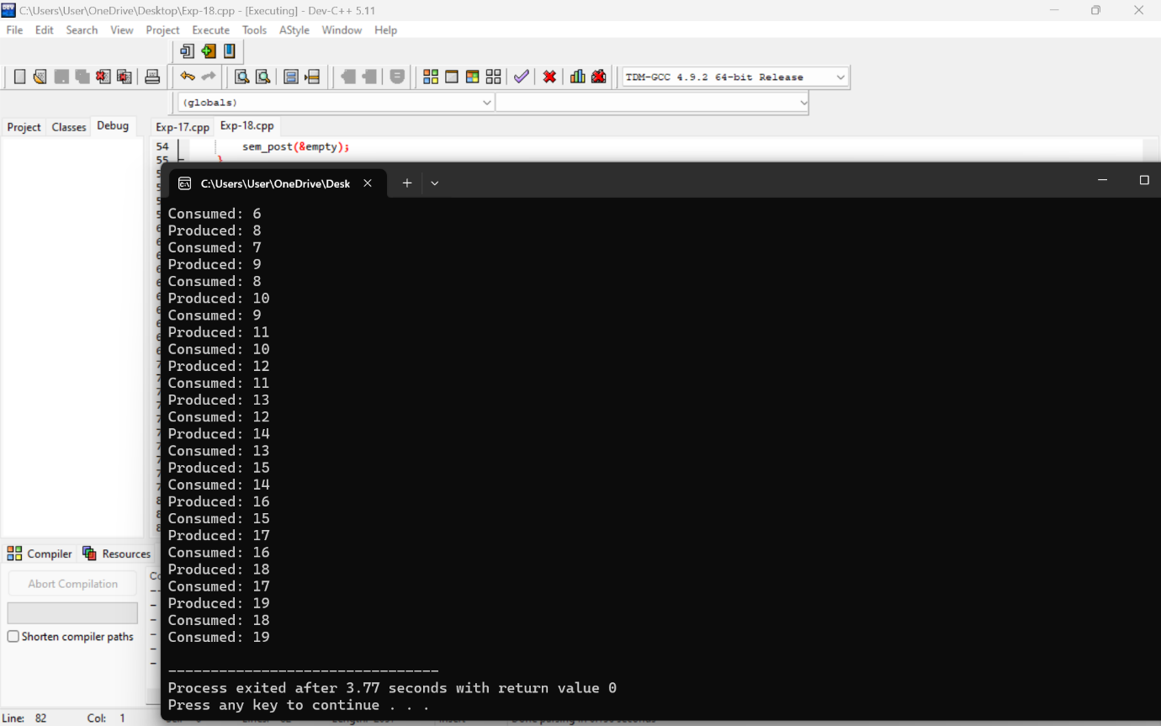

1. Design a C program to implement process synchronization using mutex locks.

PROGRAM

#include <stdio.h>

#include <stdlib.h>

#include <pthread.h>

// Shared counter

int counter = 0;

// Mutex lock

pthread_mutex_t lock;

// Function to increment the counter

void* increment(void* arg) {

for (int i = 0; i < 1000000; ++i) {

// Lock the mutex before accessing the shared counter

pthread_mutex_lock(&lock);

++counter;

// Unlock the mutex after accessing the shared counter

pthread_mutex_unlock(&lock);

}

return NULL;

}

int main() {

// Initialize the mutex lock

if (pthread_mutex_init(&lock, NULL) != 0) {

printf("Mutex initialization failed\n");

return 1;

}

pthread_t thread1, thread2;

// Create two threads

pthread_create(&thread1, NULL, increment, NULL);

pthread_create(&thread2, NULL, increment, NULL);

// Wait for both threads to finish

pthread_join(thread1, NULL);

pthread_join(thread2, NULL);

// Destroy the mutex lock

pthread_mutex_destroy(&lock);

// Print the final value of the counter

printf("Final counter value: %d\n", counter);

return 0;

}

OUTPUT

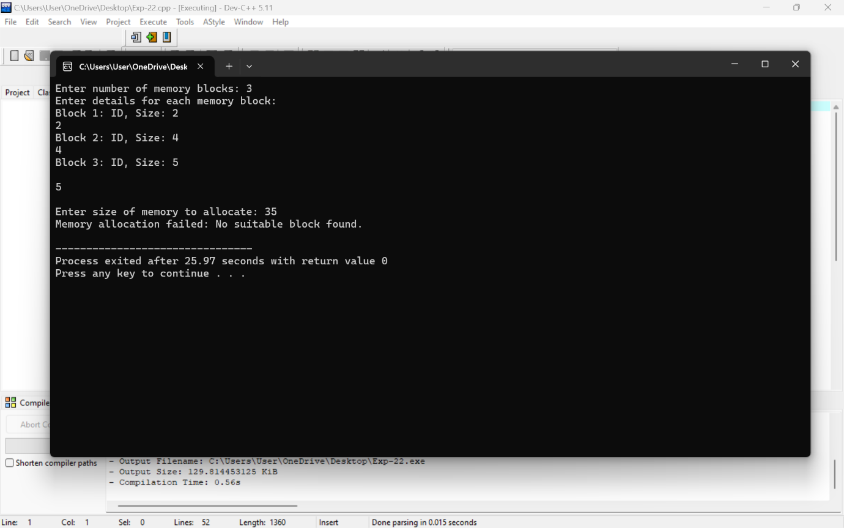

1. Construct a C program to simulate Reader-Writer problem using Semaphores.

PROGRAM

#include <stdio.h>

#include <stdlib.h>

#include <pthread.h>

#include <semaphore.h>

#include <unistd.h>

#define NUM_READERS 5

#define NUM_WRITERS 2

sem_t mutex, writeblock;

int data = 0, readers_count = 0;

void *reader(void *arg) {

int reader_id = *((int *)arg);

while (1) {

usleep(100000); // Simulate reading time

sem_wait(&mutex);

readers_count++;

if (readers_count == 1) {

sem_wait(&writeblock);

}

sem_post(&mutex);

printf("Reader %d reads data: %d\n", reader_id, data);

sem_wait(&mutex);

readers_count--;

if (readers_count == 0) {

sem_post(&writeblock);

}

sem_post(&mutex);

}

}

void *writer(void *arg) {

int writer_id = *((int *)arg);

while (1) {

usleep(1000000); // Simulate writing time

sem_wait(&writeblock);

data++;

printf("Writer %d writes data: %d\n", writer_id, data);

sem_post(&writeblock);

}

}

int main() {

pthread_t readers[NUM_READERS], writers[NUM_WRITERS];

int reader_ids[NUM_READERS], writer_ids[NUM_WRITERS];

sem_init(&mutex, 0, 1);

sem_init(&writeblock, 0, 1);

for (int i = 0; i < NUM_READERS; i++) {

reader_ids[i] = i + 1;

pthread_create(&readers[i], NULL, reader, &reader_ids[i]);

}

for (int i = 0; i < NUM_WRITERS; i++) {

writer_ids[i] = i + 1;

pthread_create(&writers[i], NULL, writer, &writer_ids[i]);

}

for (int i = 0; i < NUM_READERS; i++) {

pthread_join(readers[i], NULL);

}

for (int i = 0; i < NUM_WRITERS; i++) {

pthread_join(writers[i], NULL);

}

sem_destroy(&mutex);

sem_destroy(&writeblock);

return 0;

}

OUTPUT

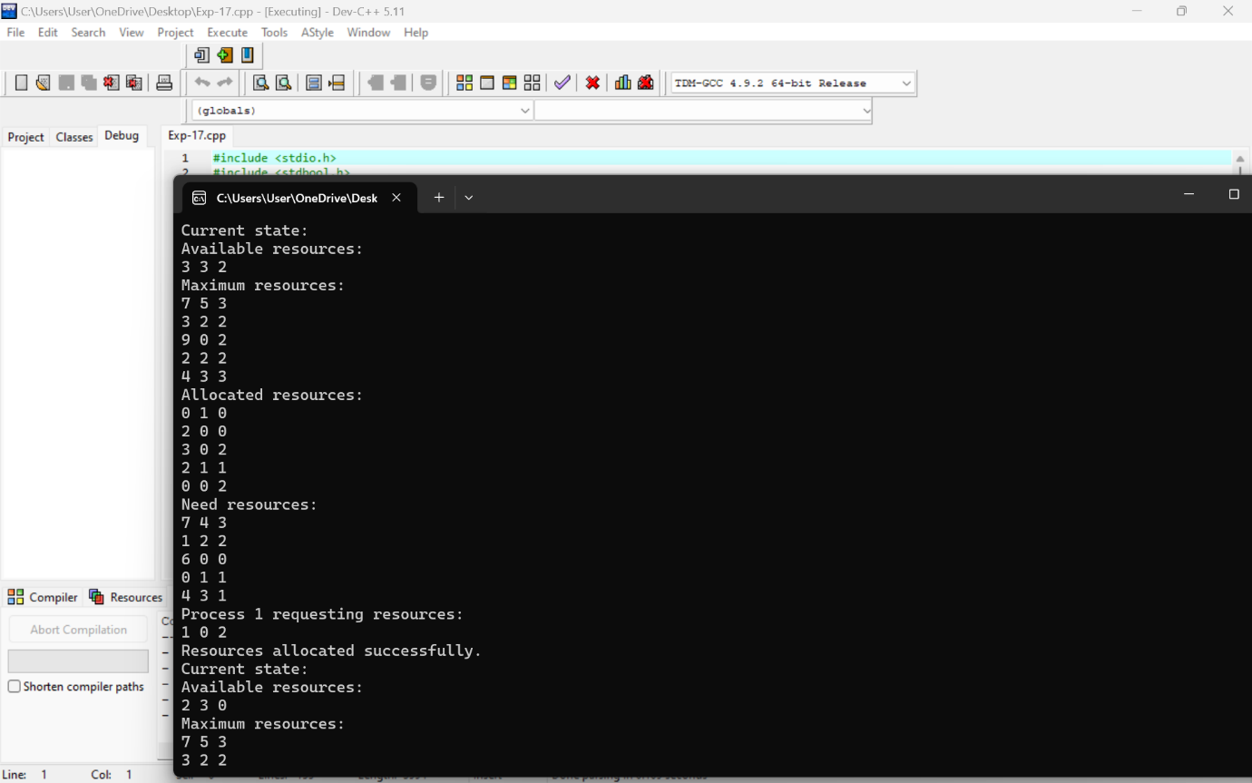

1. Develop a C program to implement worst fit algorithm of memory management.
2. Construct a C program to implement best fit algorithm of memory management.

PROGRAM

#include <stdio.h>

#include <stdlib.h>

#define MAX_PARTITIONS 50

struct MemoryPartition {

int size;

int allocated;

};

void worstFit(int blockSize[], int m, int processSize[], int n) {

struct MemoryPartition partitions[MAX_PARTITIONS];

int allocation[MAX_PARTITIONS];

// Initialize memory partitions

for (int i = 0; i < m; i++) {

partitions[i].size = blockSize[i];

partitions[i].allocated = -1; // -1 means not allocated

}

// Process each process

for (int i = 0; i < n; i++) {

// Find the worst fit partition

int worstIdx = -1;

for (int j = 0; j < m; j++) {

if (partitions[j].allocated == -1 && partitions[j].size >= processSize[i]) {

if (worstIdx == -1 || partitions[j].size > partitions[worstIdx].size) {

worstIdx = j;

}

}

}

// Allocate memory if we found a partition

if (worstIdx != -1) {

allocation[i] = worstIdx;

partitions[worstIdx].allocated = i;

} else {

allocation[i] = -1; // No suitable partition found

}

}

// Print the allocation result

printf("\nProcess No.\tProcess Size\tBlock no.\n");

for (int i = 0; i < n; i++) {

printf("%d\t\t%d\t\t", i + 1, processSize[i]);

if (allocation[i] != -1) {

printf("%d\n", allocation[i] + 1); // +1 to display block number starting from 1

} else {

printf("Not Allocated\n");

}

}

}

int main() {

int blockSize[] = {100, 500, 200, 300, 600};

int processSize[] = {212, 417, 112, 426};

int m = sizeof(blockSize) / sizeof(blockSize[0]);

int n = sizeof(processSize) / sizeof(processSize[0]);

worstFit(blockSize, m, processSize, n);

return 0;

}

OUTPUT

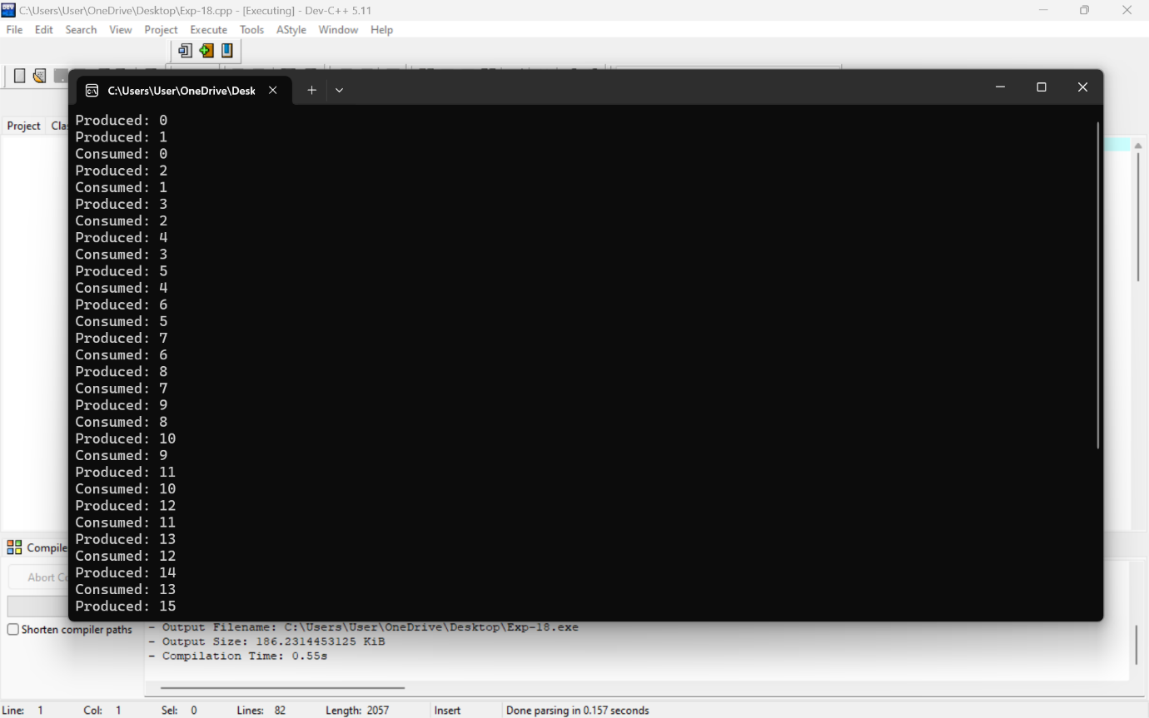

1. Construct a C program to implement first fit algorithm of memory management.

PROGRAM

#include <stdio.h>

#include <stdlib.h>

#define MAX_MEMORY 100

struct MemoryBlock {

int id;

int size;

int allocated;

};

void bestFit(struct MemoryBlock memory[], int numBlocks, int requestSize) {

int bestFitIndex = -1;

for (int i = 0; i < numBlocks; ++i) {

if (!memory[i].allocated && memory[i].size >= requestSize) {

if (bestFitIndex == -1 || memory[i].size < memory[bestFitIndex].size) {

bestFitIndex = i;

}

}

}

if (bestFitIndex == -1) {

printf("Memory allocation failed: No suitable block found.\n");

} else {

memory[bestFitIndex].allocated = 1;

printf("Memory allocated successfully at block %d.\n", bestFitIndex + 1);

}

}

int main() {

struct MemoryBlock memory[MAX_MEMORY];

int numBlocks, requestSize;

printf("Enter number of memory blocks: ");

scanf("%d", &numBlocks);

printf("Enter details for each memory block:\n");

for (int i = 0; i < numBlocks; ++i) {

printf("Block %d: ID, Size: ", i + 1);

scanf("%d %d", &memory[i].id, &memory[i].size);

memory[i].allocated = 0;

}

printf("\nEnter size of memory to allocate: ");

scanf("%d", &requestSize);

bestFit(memory, numBlocks, requestSize);

return 0;

}

OUTPUT

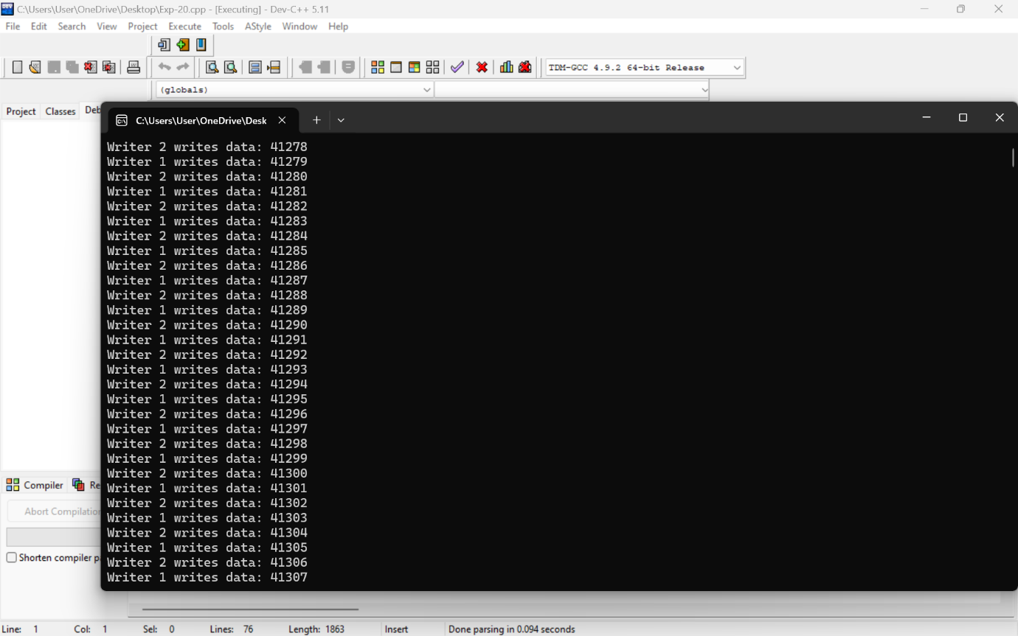

1. Design a C program to demonstrate UNIX system calls for file management.

PROGRAM

#include <stdio.h>

#include <stdlib.h>

#include <fcntl.h>

#include <unistd.h>

#include <string.h>

#define FILENAME "example.txt"

#define BUFFER_SIZE 1024

int main() {

int fd;

ssize_t bytes_written, bytes_read;

char write_buffer[] = "Hello, UNIX system calls!";

char read_buffer[BUFFER_SIZE];

// Create a new file (or open it if it already exists) with read and write permissions

fd = open(FILENAME, O_CREAT | O_WRONLY | O_TRUNC, S_IRUSR | S_IWUSR);

if (fd == -1) {

perror("Error opening file for writing");

exit(EXIT_FAILURE);

}

// Write data to the file

bytes_written = write(fd, write_buffer, strlen(write_buffer));

if (bytes_written == -1) {

perror("Error writing to file");

close(fd);

exit(EXIT_FAILURE);

}

printf("Wrote %ld bytes to %s\n", bytes_written, FILENAME);

// Close the file

if (close(fd) == -1) {

perror("Error closing file after writing");

exit(EXIT_FAILURE);

}

// Open the file for reading

fd = open(FILENAME, O_RDONLY);

if (fd == -1) {

perror("Error opening file for reading");

exit(EXIT_FAILURE);

}

// Read data from the file

bytes_read = read(fd, read_buffer, BUFFER_SIZE - 1);

if (bytes_read == -1) {

perror("Error reading from file");

close(fd);

exit(EXIT_FAILURE);

}

// Null-terminate the read buffer to make it a proper string

read_buffer[bytes_read] = '\0';

printf("Read %ld bytes from %s: %s\n", bytes_read, FILENAME, read_buffer);

// Close the file

if (close(fd) == -1) {

perror("Error closing file after reading");

exit(EXIT_FAILURE);

}

// Delete the file

if (unlink(FILENAME) == -1) {

perror("Error deleting file");

exit(EXIT_FAILURE);

}

printf("Deleted %s\n", FILENAME);

return 0;

}

OUTPUT

